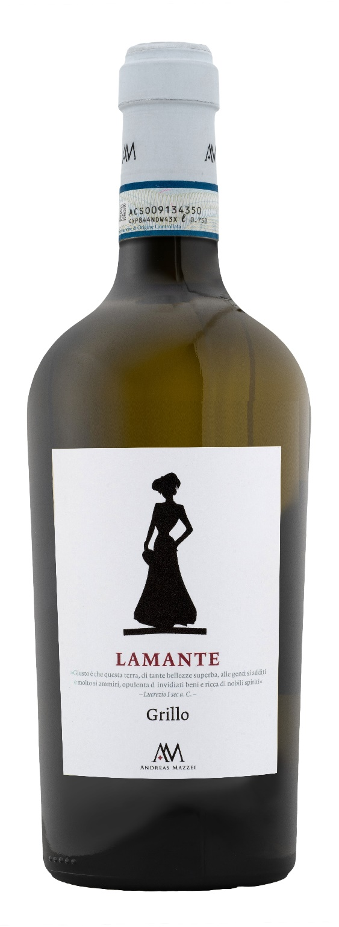
GRILLO DOP – L’AMANTE
Grillo is certainly one of the protagonists among Sicilian white wines, it impresses with its long-lasting finish and its elegance. The wine enchants like a lover (translated L'AMANTE) with its unique scents and expressive taste. A wine with a strong and rich character. It has a delicate bouquet of fine notes of tropical fruits. On the palate it is determined and authentic, an unforgettable wine experience.

Grape: Grillo 100%
Alc. Vol.%: 13,5
Vintage: 2025
Residual sugar g/l: 5,0
Total acidity g/l: 6,3
Region: Sicily
Production zone: Vineyards in the province of Trapani
Capacity: 750ml

CHARACTERISTICS

Vinification: Short crio-maceration of the skins, then fermentation in steel tanks at a controlled temperature
Aging: Once the fermentation is over the wine is conserved in steel tanks at a controlled temperature of 16°C till bottling
Yield per ha: 9000kg
Colour: Bright straw-yellow with greenish reflections
Bouquet: Important notes of exotic fruits, peach and pineapple
Flavour: Smooth, structured and elegant

SERVING SUGGESTIONS

Best enjoyed with soups, grilled fish plates and white meat.
Serving temperature 8 °C
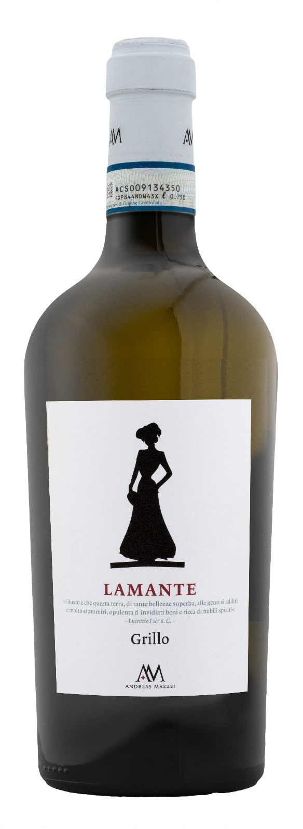
TECHNICAL INFORMATION / PALLETIZING

Size 750ml:
Article Nr. V04005A
GTIN-13 bottle 8017868004714
GTIN-13 carton 8017868005902
Closure Cork
Bottles / carton 6 bottles
Pallet size 80x120cm
Cartons/layer 17
Cartons/pallet 102
Kg/carton 8,4
Kg/pallet 880

Contains sulphites
GMO Free
Revisione 01. 20.10.2026

